**634 State Road 19 PO Box 37, Marshall, WI 53559 www.townofmedina.wi.gov**

**NOTICE OF TOWN**

**BOARD QUORUM**

**A quorum of the Medina Town Board of Supervisors may be present at the Town of Medina Planning Commission Meeting**

**Tuesday, August 6, 2024, 7:00 PM**

**Medina Town Hall**

**634 State Road 19**

**Marshall, WI 53559**

**No action will be taken by the Medina Town Board of Supervisors at this meeting.**

Posted Monday August 5, 2024; townofmedina.wi.gov, Medina Town Hall, Whisper’s Roadhouse and The Barrel Inn.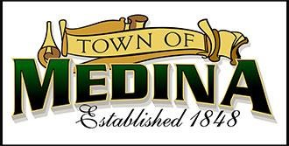

Upon reasonable notice, efforts will be made to accommodate the needs of disabled individuals through appropriate aids & services. For additional information or to request this service, contact the Town Clerk-Treasurer at 608-219-3556 or email at [clerk@townofmedina.wi.gov](mailto:clerk@townofmedina.wi.gov)

By: Stephanie Lulling, Clerk/Treasurer – Town of Medina