**634 State Road 19 PO Box 37, Marshall, WI 53559 www.townofmedina.wi.gov**

TOWN OF MEDINA

MEETING OF THE PLANNING COMMISSION

Tuesday, August 27, 2024, 7:00 PM

Medina Town Hall

1. Call to Order
2. Pledge of Allegiance
3. Recognize Those in Attendance
4. 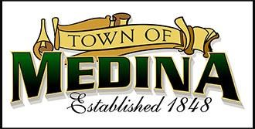Posting: Planning Commission Meeting Posted August 19, 2024 Town Hall, townofmedina.wi.gov, Whisper’s Roadhouse and Barrel Inn
5. Public Appearances
6. Approval of Minutes of Previous Meeting
7. Rezone Permit Application – Van Holten’s Inc., East of 211 Canal Road

Parcel #: 036/0812-122-8011-0 (34.643 acres)

Current Zoning: Farmland Preservation-35 (FP-35)

Proposed Zoning: Farmland Preservation-Business (FP-B) 16.4 acres

Farmland Preservation-1 (FP-1) 18.6 acres

Intended Use: New Pickle Fermentation Business Site

1. Adjournment

*Discussion and Action may occur on any of the above Agenda items.*

The above item(s) may be presented to the Medina Town Board of Supervisors at their next monthly meeting on September 11, 2024

Upon reasonable notice, efforts will be made to accommodate the needs of disabled individuals through appropriate aids & services. For additional information or to request this service, contact the Town Clerk-Treasurer at 608-219-3556 or email at [clerk@townofmedina.wi.gov](mailto:clerk@townofmedina.wi.gov)

By: Stephanie Lulling, Clerk/Treasurer – Town of Medina