**634 State Road 19 PO Box 37, Marshall, WI 53559 www.townofmedina.wi.gov**

TOWN OF MEDINA

Special Meeting of the Board of Supervisors

Town of Medina – Town Hall

Tuesday October 15th, 2024

5:30 PM

1. Call to Order
2. Pledge of Allegiance
3. Recognize Those in Attendance
4. 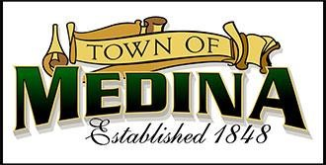Posting: Monthly Town Board Meeting Friday, October 11th, 2024, Town Hall, Townofmedina.wi.gov, Whisper’s Roadhouse and Barrel Inn
5. Road User Agreement
6. Van Holten’s Rezone Application
7. Adjournment

*Discussion and Action may occur on any of the above Agenda items.* Upon reasonable notice, efforts will be made to accommodate the needs of disabled individuals through appropriate aids & services. For additional information or to request this service, contact the Town Clerk at 608-219-3556 or email at clerk@townofmedina.wi.gov

By: Stephanie Lulling, Clerk/Treasurer – Town of Medina

**634 State Road 19 PO Box 37, Marshall, WI 53559 www.townofmedina.wi.gov**