**634 State Road 19 PO Box 37, Marshall, WI 53559 www.townofmedina.wi.gov**

TOWN OF MEDINA

SPECIAL MEETING OF THE BOARD OF SUPERVISORS

Town of Medina – Town Hall

Monday, November 18th, 2024

6:00 PM

1. Call to Order
2. Pledge of Allegiance
3. Recognize Those in Attendance
4. 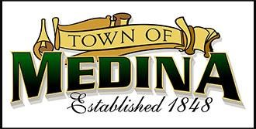Posting: Monthly Town Board Meeting Friday, November 15th, 2024, Town Hall, Townofmedina.wi.gov, Whisper’s Roadhouse and Barrel Inn
5. Public Appearances
6. Correspondence for Board
7. Meeting Minutes from October 13, 2024, meeting
8. Budget discussion.
9. ARPA funds
10. Spring election.
11. Items for Future Meetings

12.Adjournment

*Discussion and Action may occur on any of the above Agenda items.* Upon reasonable notice, efforts will be made to accommodate the needs of disabled individuals through appropriate aids & services. For additional information or to request this service, contact the Town Clerk at 608-219-3556 or email at clerk@townofmedina.wi.gov

By: Stephanie Lulling, Clerk/Treasurer – Town of Medina

**634 State Road 19 PO Box 37, Marshall, WI 53559 www.townofmedina.wi.gov**