**634 State Road 19 PO Box 37, Marshall, WI 53559 www.townofmedina.wi.gov**

TOWN OF MEDINA

MONTHLY MEETING OF THE BOARD OF SUPERVISORS

Town of Medina – Town Hall

Wednesday, December 11th, 2024

6:00 PM

1. Call to Order
2. Pledge of Allegiance
3. Recognize Those in Attendance
4. 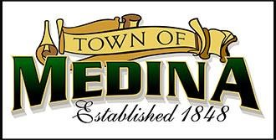Posting: Monthly Town Board Meeting Monday, December 9th, 2024, Town Hall, Townofmedina.wi.gov, Whisper’s Roadhouse and Barrel Inn
5. Public Appearances
6. Correspondence for Board
7. Road Grants/Updates-Lukasz Lywza
8. Meeting Minutes from November 13th, 2024, meeting
9. Monthly checks.
10. Streetlight- Berlin Road/Hwy TT.
11. Set Caucus Date and Confirm candidates
12. Planning Commission updates.
13. Boring under the roadway.
14. Highway Report.
15. EMS and Fire Commission Reports.
16. Clerk/Treasurer Report.
17. Items for Future Meetings

18.Adjournment

*Discussion and Action may occur on any of the above Agenda items.* Upon reasonable notice, efforts will be made to accommodate the needs of disabled individuals through appropriate aids & services. For additional information or to request this service, contact the Town Clerk at 608-219-3556 or email at clerk@townofmedina.wi.gov

By: Stephanie Lulling, Clerk/Treasurer – Town of Medina

**634 State Road 19 PO Box 37, Marshall, WI 53559 www.townofmedina.wi.gov**