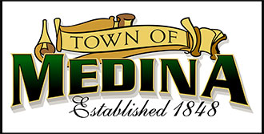**634 State Road 19 PO Box 37, Marshall, WI 5355**

**NOTICE TOWN OF MEDINA CAUCUS**

**WEDNESDAY JANUARY 8th, 2025, 6:00 PM**

**NOTICE IS HEREBY GIVEN to the electors of the Town of Medina, in the County of Dane, State of Wisconsin, that a Town Caucus for the Town of Medina will be held at the Medina Town Hall, 634 E. Main St., Hwy 19, Marshall WI on Wednesday, January 8th, 2025, at 6:00 PM, to nominate candidates for town offices to be voted on at the Spring Election to be held on Tuesday April 1st, 2025.**

**Offices for Nomination (2-year terms):**

**Chairman**

**(Incumbent – Todd Weinberger)**

**Supervisor**

**(Incumbent – John Hellenbrand)**

**Supervisor**

**Open Seat**

Stephanie Lulling- Town of Medina Clerk/Treasurer

December 18th, 2024